Part A
Brownie Premix / 布朗尼预混粉 | 250gm
Egg / 全蛋 / Telur | 2 nos
Milk / 牛奶 / Susu Segar | 50gm
Unsalted Butter (melted) / 无盐奶油 (融化状) / Mentega (dicairkan) | 100gm
Dark Chocolate (melted) / 黑巧克力 (融化状) / / Coklat Gelap (dicairkan) | 50gm
Part B
Lacto Orange & Lemon Cheese | 250gm
Castor Sugar / 砂糖 / Gula Kastor | 20gm
Dairy Cream / 动物性奶油 / Krim Tenusu | 100gm
Egg Yolk / 蛋黄 / Kuning Telur | 1 nos
LACTO RECIPE
Cheesy Crown Brownies
*make about 14 pcs / 能做 14 个小蛋糕 / saiz hidangan: 14 cawan
Method
1. Combine all ingredients of part A in bowl and mix well.
2. Line paper cup in muffin tin, scoop the batter into the paper cup and baked in preheated 170˚C oven for about 15 minutes.
3. Make a hole in the middle of the baked brownie with spoon and leave the brownies to cool.
4. Cream Lacto Orange & Lemon Cheese and sugar on high speed 4 minutes till fluffy
5. Add in Dairy Cream and continue mix with high speed for 4 minutes
6. Add Egg Yolk and mix with medium speed for 3 minutes. Place the filling into piping bag and keep chill if not use.
7. Combine part C in bowl and mix well, keep aside
8. Pipe the filling into the brownies and spread to cover the surface.
9. Egg wash the top and steam bake in preheated 210˚c oven for 10 - 12 minutes
10. Serve hot for cheese lava effect; serve chill for cheesecake texture.
Method
1. 将所有part A的材料放入碗里搅拌至均匀。
2. 把面糊倒入装有纸模的松饼模具, 然后放入预热170˚c烤箱烘烤大约15分钟。
3. 当蛋糕烘烤完成后用一把汤匙在蛋糕的中央压一个洞，然后让蛋糕自然冷却
4. 用搅拌器把Lacto Orange & Lemon cheese 打发4分钟。
5. 打发后加入动物性奶油，再继续以高速打发4分钟
6. 加入蛋黄然后以中速搅拌3分钟至均匀。之后把芝士糊放入挤压袋预冷备用。
7. 把part C(蛋水) 的材料搅拌均匀， 备用。
8. 将芝士糊挤入压好的蛋糕中央形成内陷，然后再把芝士糊均匀地抹在蛋糕的表面。
9. 用刷子把蛋水均匀地擦在芝士糊上，然后放入预热210˚c烤箱以蒸烤法烘烤10-12分钟。
10. 热食享用将有芝士流沙的效果；如冷藏后将会如同芝士蛋糕的效果。
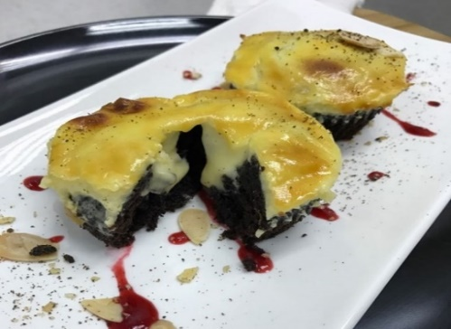
Cara
1. Satukan semua bahan dalam bahagian A dalam mangkuk dan kacau sebati.
2. Susun cawan kertas ke dalam acuan ‘muffin’, kemudian masukkan adunan ke dalam setiap cawan kertas dan bakar pada suhu 170 ˚C selama 15 minit.
3. Keluarkan brownie dari oven dan buat satu lubang di tengah-tengah brownie dengan menggunakan sudu kecil (ketika masih panas), kemudian biarkan seketika sehingga sejuk.
4. Putar Lacto Orange & Lemon Cheese dan Gula dengan kelajuan tinggi selama 4 minit sehingga kembang.
5. Masukkan Krim Tenusu ke dalam adunan tadi dan teruskan putar dengan kelajuan tinggi selama 4 minit.
6. Masukkan pula Kuning Telur dan sebatikan dengan kelajuan sederhana selama 3 minit. Masukkan ‘filling’ ke dalam ‘piping bag’ dan sila simpan di dalam peti sejuk jika tidak digunakan.
7. Satukan bahagian C di dalam mangkuk kecil dan kacau sebati.
8. Paipkan ‘filling’ ke dalam brownie dan ratakan permukaan sehingga sekata.
9. Letakkan sapuan telur di atas brownie dan stim bakar pada suhu 210 ˚C selama 10-12minit.
10. Hidangkan panas untuk kesan keju meleleh; hidangkan sejuk untuk tekstur seperti kek keju.
Part C (egg wash) / (sapuan telur) /
(蛋水)
Egg Yolk / 蛋黄 / Kuning Telur | 1 nos
Dairy Cream / 动物性奶油 / Krim Tenusu | 10gm
Castor Sugar / 幼糖 / Gula Kastor | 5gm

